**Artificial Intelligence and Machine Learning**

**LAB 7**

**Name: PUNEETH L**

**USN: 1BM24MC069**

7. Implement KNN Classification algorithm on a dataset. Analyse the model using different K values and display the performance of the model.

Program:

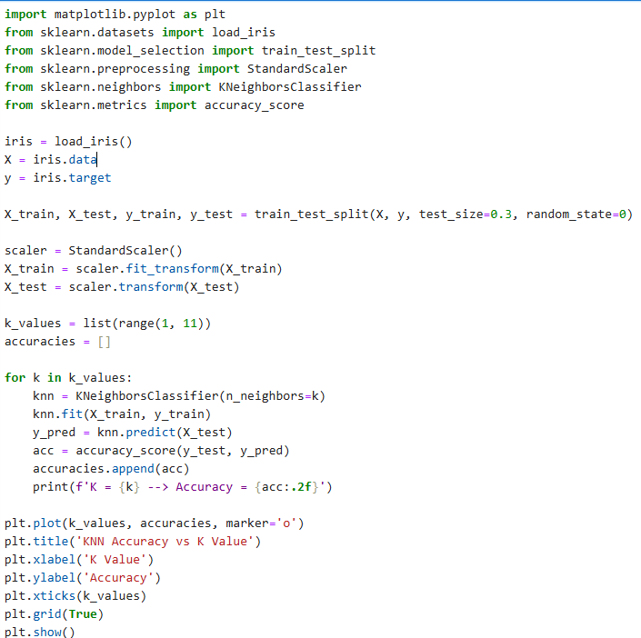

Output:

